HW1: Mid-term assignment report
Filipe Miguel Neto Viseu [119192], v2025-11-05

1 Introduction 1
1.1 Overview of the work 1
1.2 Current implementation (faults & extras) 1
2 Product specification 2
2.1 Functional scope and supported interactions 2
2.2 System implementation architecture 3
2.3 API for developers 4
3 Quality assurance 4
3.1 Overall strategy for testing 4
3.2 Unit and integration testing 5
3.3 Acceptance testing 7
3.4 Non-functional testing 7
3.5 Code quality analysis 8
3.6 Continuous integration pipeline [optional] 8
4 References & resources 9

Introduction

Overview of the work
This report presents the midterm individual project required for TQS, covering both the software product features and the adopted quality assurance strategy.
ZeroMonos is a waste collection management system designed to simplify the scheduling and management of waste collection across Portuguese municipalities (Aveiro does something similar “Retomado o serviço de recolha de volumosos e resíduos verdes”.
My application enables citizens to book waste collection appointments while providing staff with tools to monitor, filter and update booking status.

Current implementation (faults & extras)
Faults/Limitations:
- No authentication
- The CORS is set to [*] (couldn’t be if this went to production)

Extras:
- Modern and responsive UI
- Assign work to employees
- Operations dashbord

Use of generative AI
The use of AI in my work was mostly to make some of the frontend stuff.
I made the structure of the HTML code but I asked AI to make it prettier.
Also, in some tests I used AI to help me (for example in WebFunctionalTest where I was having trouble to put the date and I asked AI that gave me the option of “Javascript Executor”).
Besides that, the 100 tests I have weren’t all made by hand, I made 50 tests and asked AI to help me make the other 50 (Employee and WorkTask tests). This was very helpful but it wasn’t perfect, AI made a lot of mistakes that had to be corrected by me.

Product specification

Functional scope and supported interactions
Citizens:
- Create bookings
- Track booking status with token
- View booking history
- Cancel existing bookings

Staff:
- View all bookings
- Filter bookings by municipality and by status
- Update booking status

Employee:
- 4 functions: DRIVER, COLLECTOR, SUPERVISOR, ADMIN
- Can be assigned to a booking

Main interactions (Citizen):
- Access citizen portal from the “index” page
- Fill booking form (description, municipality and date)
- Receive token
- Track booking with token (In “My Bookings” tab)
- View status update and cancel booking if needed

Main interactions (Staff):
- Access staff portal from the “index” page
- Load and filter bookings by municipality or by status
- Update booking status
- Add employees to DB
- Assign booking to employees

System implementation architecture
My system follows a layered architecture:
It consists of a Maven project using Spring Boot named backend where all the backend stuff is and a folder named frontend with HTML, JS and CSS code.
Inside backend I chose to create 3 folders (representing layers):
- Boundary - contains the BookingController that exposes REST endpoints for operations & WorkTaskController & EmployeeController (same logic)
- Service - contains the BookingService that implements the business logic (functions used by BookingController endpoints) & WorkTaskService (same logic)
- Data - contains the BookingRepository (that extends JPARepository), BookingRequest an Entity mapped to the DB using JPA and BookingHistoryRepository & BookingHistoryRequest to keep track of states
WorkTaskRepository & WorkRequest & EmployeeRepository & EmployeeRequest

In general, I used
- Spring Boot 3.5.6
- Spring Data JPA
- REST Assured 5.4.0
- PostgresSQL
- HTML, CSS, JS
- K6

API for developers

Endpoints | Methods | Description
/api/bookings | POST | Create new booking
/api/bookings | GET | Get all bookings
/api/bookings/{token} | GET | Get specific booking
/api/bookings/{token}/cancel | PUT | Update status to canceled
/api/bookings/{token}/status | PUT | Update booking status
/api/bookings/{token}/history | GET | Get booking status history

Example (Create Booking):

POST /api/bookings
{
"description": "Large furniture disposal",
"municipality": "Aveiro",
"date": "2025-12-25T10:00:00"
}

Quality assurance

Overall strategy for testing
Multi-layered strategy.

Unit Tests
- Tools: JUnit 5, Mockito
- Focus: Testing business logic in isolation
- Approach:
- Mocked repository dependencies to test service layer logic independently
- Validated core business rules (e.g., booking limits, status transitions)
- Fast execution, no external dependencies

Integration Tests
- Tools: REST-Assured, Spring Boot Test, JdbcTemplate
- Focus: Testing API endpoints with real database interactions
- Approach:
- REST-Assured for clean, readable HTTP request/response validation
- Database cleanup using JdbcTemplate
- Verified complete request-response cycles including data persistence

Controller Tests
- Tools: MockMvc , MockitoBean
- Focus & Approach: Test controllers mocking services layers

Functional E2E Tests
- Tools: Selenium WebDriver
- Focus: Test complete workflows
- Approach: Simulated real user interactions, testing all system

Performance Tests
- Tools: K6
- Focus: Validate system behavior
- Approach: LoadTests, SpikeTests, StressTests

Unit and integration testing
Unit Tests were used on BookingServiceTest & WorkServiceTest:
- Tests business logic in isolation
- Uses Mockito to mock the repositorys
- Validates booking creation, token generation, booking limits, status history checking
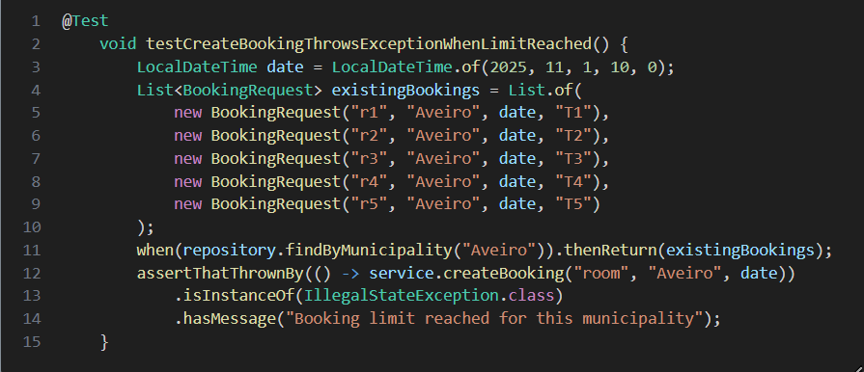

Controller Tests were used on BookingControllerTest & EmployeeControlerTest & WorkControllerTest :
- Uses WebMvcTest and MockMvc
- Tests Endpoints, request validations and response formats
- Validate status codes (200, 400, etc.)
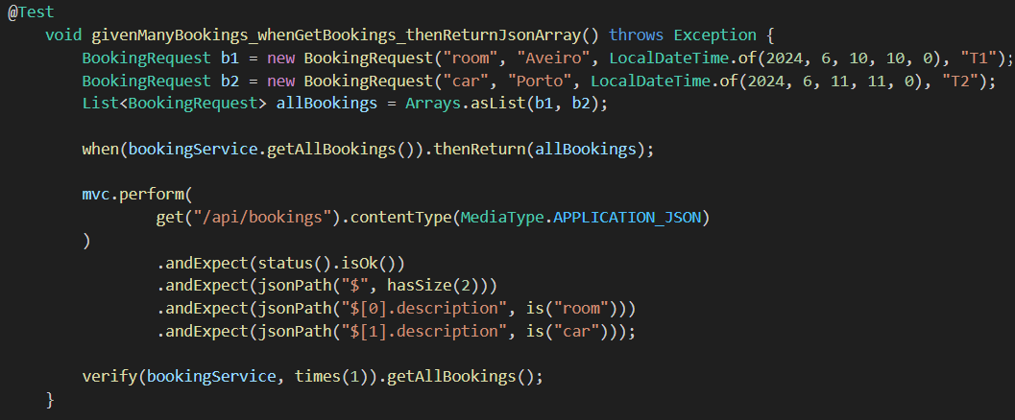

Integration Tests were used on BookingControllerIT, EmployeeControllerIT, WorkControllerIT:
- Uses Rest Assured for full API testing
- Tests actual HTTP requests (no mock)
- Validates the complete “lifecycle”

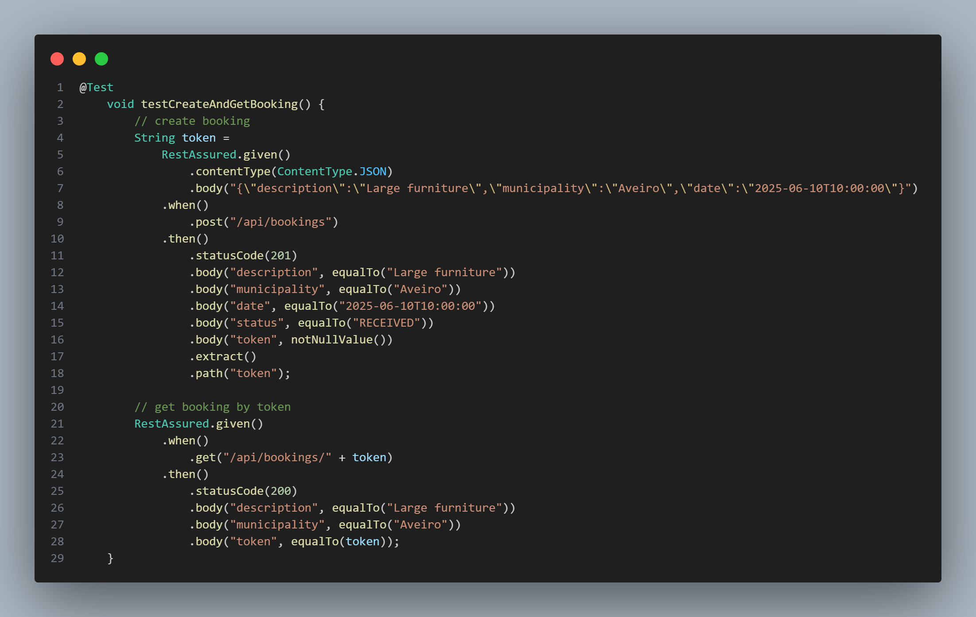

Acceptance testing
Functional Tests were implemented in WebFunctionalTest:
- Implemented using Selenium WebDriver with @ExtendWith(SeleniumJupiter.class)
- Automatic driver management

Test Cases:
- testCreateBookingAsCititzen: Validates de booking creation workflow
- testSearchBooking: Tests the search functionality
- testStaffPortalAcess: Validates the staff interface and bookings loading
- testRoleSwitching: Switch between user and staff
- testMunicipalityFilter: Test the filtering option in staff
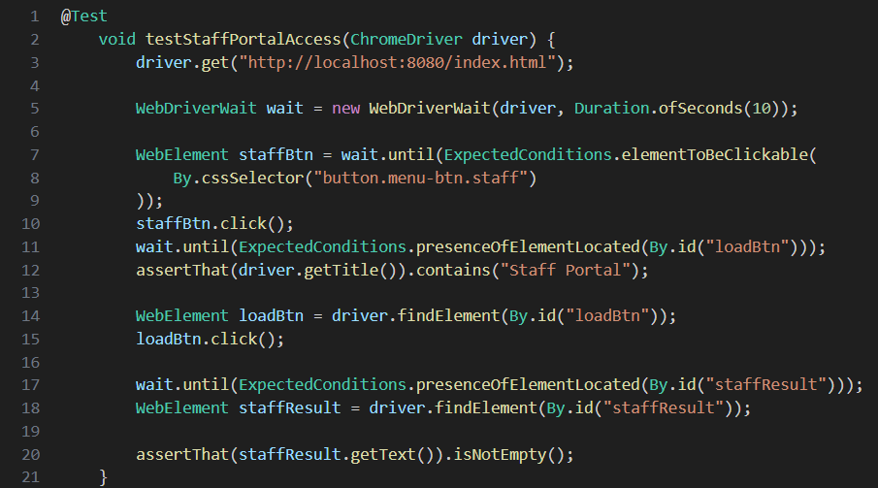

Non-functional testing
I tested the performance of my system using K6 (studied in TP classes)
LoadTest:
- Gradual ramp-up to 20 users
- Sustain 20 users for 30 seconds
- Test operations
- Thresholds
SpikeTest:
- Sudden spike from 10 to 100 users
- Test the behavior with that amount of users
StressTest:
- Incremental load ; Breaking point ; System stability

Code quality analysis
I used sonarqube, local and web (with a public github project).
In this analysis I saw problems like CORS for example that in this case it isn’t a real problem but if this application goes to production, then it turns a problem.
Other problems were security ones in logs where user input were being logged directly, creating a potential log injection vulnerability.

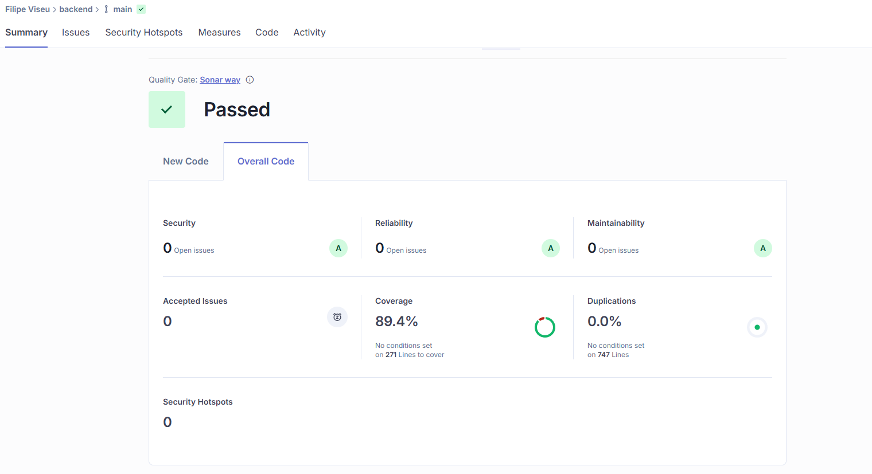

Continuous integration pipeline [optional]
I used github actions and sonarqube.

1. Automated Testing
- Runs on every push to `main` branch and pull requests
- Executes unit tests, integration tests (Selenium tests excluded in CI)
- PostgreSQL service container for database-dependent tests

2. Code Quality Analysis
- SonarCloud integration for code quality metrics
- Code coverage tracking with JaCoCo
- Automated quality gate checks

References & resources
Project resources
Resource: | URL/location:
Video demo | docs/ZeroMonosDemo
QA dashboard (online) | https://sonarcloud.io/summary/overall?id=FilipeNV1_ZeroMonos119192&branch=main
CI/CD pipeline | https://github.com/FilipeNV1/ZeroMonos119192/actions

Reference materials

Geo API: https://geoapi.pt/docs/
REST Assured: https://www.geeksforgeeks.org/software-testing/how-to-test-api-with-rest-assured/

